Grade 7 Accelerated · Unit 4 · Lesson 1  Adding and Subtracting in Scientific Notation  Question Bank - Additional 4.01 ANSWER KEY | Name  Date  Period

Show your work. Circle your final answer.
For questions 1 through 6, add or subtract. Write each answer in scientific notation.
1. 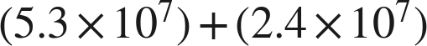


2.


3. 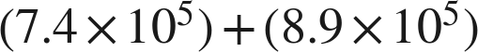

4.

Point one place right, exponent down one.

5. 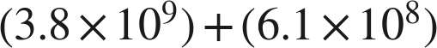

.

6.

.

Real quantities.
7. Mars's diameter is about 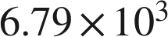 kilometers. Earth's is about  kilometers.
a. What is the sum of the two diameters?
 km
.
b. How much larger is Earth's diameter than Mars's?
 km
, and .

8. A charity raised about 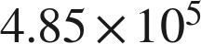 dollars in its first year and about  dollars in its second.
a. How much did it raise in the two years together?
 dollars
.
b. How much more did it raise in the second year than in the first?
 dollars
.

Working backwards.
9. Find the missing number in each equation.
a.
n = 8.2
.
b.
n = 5.8
c. 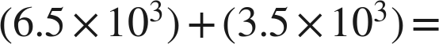 ______

The coefficients sum to exactly 10.

Reading someone else's work.
10. Malik writes . Name the two mistakes he made, and give the correct sum.
He added the coefficients without first writing both numbers over the same power of ten, and he added the exponents. The correct sum is .
, and . His  was then repaired correctly to  — the repair is the one thing he did right.

11. Which is the value of 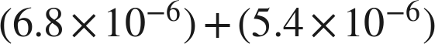, written in scientific notation?
● A. 
○ B. 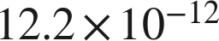
○ C. 
○ D. 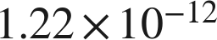
A

12. Select ALL of the expressions whose value is 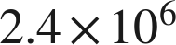.
☒ A. 
☐ B. 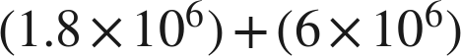
☒ C. 
☒ D. 
☒ E. 
☐ F. 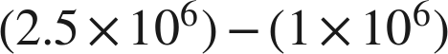
A, C, D and E

